Saint John of God Community Services Dublin South East

St. John of God Dublin South East Services provides a network of education, training, employment, respite, community living supports and rights promotion to children and adults with intellectual disabilities in South Dublin.

Social Care Worker – Adult Residential Services
Relief Posts available

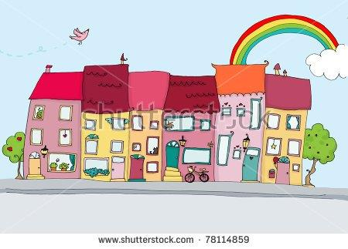

Candidates who would like to support the men and women attending our service should have the following:
- Bachelor of Arts in Applied Social Studies/Social Care or equivalent
- A proven track record in the delivery of Person Centered systems, services and supports and awareness of positive behavior supports
- Excellent knowledge and understanding of relevant Health Act Regulations, HIQA Standards and all other relevant legislation
- Experience of working with people who have an intellectual disability (experience supporting Service Users with higher needs advantageous)
- Experience of a residential setting is desirable
- Be innovative, resourceful, flexible and have excellent communication, interpersonal,
administrative and co-ordination skills.
- Ability to work both in a busy team environment and independently.
- Ability to support and facilitate independent living and community integration.
- Experience in the area of human rights and advocacy.
- Full manual driving license is essential

Please forward your covering letter and CV by email only to dserecruitment@sjog.ie Quoting REF: SCWreliefnov22

Informal enquiries to Michelle Genoe Tel: 01 285 2900
Shortlisting will apply.
– Compassion – Excellence – Justice
Saint John of God Community Services CLG is an equal opportunities employer.
We operate HSE (Health Service Executive) funded services across Intellectual Disability, Adult Mental Health and Child and Adolescent Psychiatry.

Hospitality Respect Compassion

